Software Requirements Specification
for
<Campus Recruitment Management System>
Version 1.0 approved
Prepared by ANEETA THOMAS
Amal Jyothi College of Engineering
30-09-2019
Table of Contents
Table of Contents ii
Revision History ii
1. Introduction 1
1.1 Purpose 1
1.2 Document Conventions 1
1.3 Intended Audience and Reading Suggestions 1
1.4 Product Scope 1
1.5 References 1
2. Overall Description 2
2.1 Product Perspective 2
2.2 Product Functions 2
2.3 User Classes and Characteristics 2
2.4 Operating Environment 2
2.5 Design and Implementation Constraints 2
2.6 User Documentation 2
2.7 Assumptions and Dependencies 3
3. External Interface Requirements 3
3.1 User Interfaces 3
3.2 Hardware Interfaces 3
3.3 Software Interfaces 3
3.4 Communications Interfaces 3
4. System Features 4
4.1 System Feature 1 4
4.2 System Feature 2 (and so on) 4
5. Other Nonfunctional Requirements 4
5.1 Performance Requirements 4
5.2 Safety Requirements 5
5.3 Security Requirements 5
5.4 Software Quality Attributes 5
5.5 Business Rules 5
6. Other Requirements 5
Appendix A: Glossary 5
Appendix B: Analysis Models 5
Appendix C: To Be Determined List 6

Revision History
Name | Date | Reason For Changes | Version

Introduction

Purpose
The project is beneficial for college students, various companies visiting the campus for recruitment and even the college placement officer. The software system allows the students to create their profiles and upload all their details including their marks onto the system.

Document Conventions
Heading: Font Size: 16
Font Style: Bold
Font: Times New Roman

Sub Heading:
Font Size: 14
Font Style: Bold
Font: Times New Roman

Content:
Font Size: 12
Font: Times New Roman

Intended Audience and Reading Suggestions
The intended audience of this document includes the companies and the students looking for On- placements. This will be knowledgeable to company HR to understand the college efficiently. Information displayed, and other statistical information will attract new admission and a clear picture with records will be maintained with this portal.

Product Scope
The System would store all the academic as well as personal details of the students who wish to be placed and the Companies who offer jobs to the students. The details of the Companies as well as the students may be updated or modified or deleted to keep the information up to date. Also, notifications would be sent to the students about the Companies i.e. details like the Company profile, eligibility criteria for the job profile etc. Also, the information regarding the Placement activities or procedure for a particular Company i.e. the selection rounds or procedure.

References

Overall Description
This project is to facilitate students in college, company to register and communicate with Placement Office of college. The users can easily access the data and it can be retrieved easily in no time.

Product Perspective
- In various colleges, training and placement officers have to manage the students’ profiles and the documents of students for their training and placement manually.
- Also Placement Officers have to collect the information of various companies who want to recruit students and notify students time to time about the placements.
- Placement Officer also have to arrange profiles of students according to various streams and notify them according to company requirements.
- If any modifications or updates are required in the profile of the students or the Company, it has to be searched and done manually.
- Hence the Placement Management System would maintain a huge database for the complete details of the students as well as the Companies in the Placement process which would help to save time and effort.

Product Functions
- The campus recruitment Management System is to be developed as an attempt to take a record of Companies and students by restricting a large database that would be used for each.
- The System would provide the facility of viewing both the personal and academic information of the students and also the company.
- The System would also be able to search for eligible students and company with respect to their specifications and requirements.
- The eligible students would receive an email including the details of the Company, placement procedure and other details.

User Classes and Characteristics
The major User classes in the System would be:
1. Student
- New Student needs to sign up or register giving complete details
- They can submit resume and update profile information.
- They can register for a particular Company.
2. Administrator
- The Admin has the supreme power of the application
- Admin provides approval to the Student and the Corporate registration
- Admin is responsible for maintaining and updating the whole system.
- Admin has the responsibility to notify the Company for any application from a student.
- Admin has to notify the students regarding any changes in the procedure or selection.
3. Company
- The Company has to notify the Admin or the Placement officer.
- The Company initially has to sign up.
- The Company may shortlist the students who applied.

Operating Environment
This web application can be deployed on Linux or window machine with Apache Server and MySQL server.
• Minimum RAM 512MB
• 20GB Storage Space.
• Intel Dual Core Processor
• Internet Connectivity with Ports configured
This application can be accessed by user through a machine having any web browser with html JavaScript support and flash to get video content

Design and Implementation Constraints
Design Constraints:
Security: The files in which the information regarding securities and portfolios should be secured against malicious deformations

User Documentation
User documentation components such as user manuals, on-line help, and tutorials will be delivered along with
the software. Manual can be downloaded along the CMS package. Other tutorials and support form will be
made available in case to report any bug or other support related issues.

Assumptions and Dependencies
We are assuming that the user should have some basic knowledge of computer.

External Interface Requirements

user Interfaces
the program will communicate with user in a user friendly manner that would take less amount of time to access the system

Hardware Interfaces
The program will communicate with hard drive (the filesystem and database) via the appropriate PHP code. The user can communicate through browser using keyboard and a display through graphical interface displayed on user’s screen.

Software Interfaces
Operating system: windows
Web Server: Apache 2.2.4
Database: MySQL 5.0
Scripting Language: HTML, JavaScript
Web Browser: Mozilla Firefox

Communications Interfaces
The requirements associated with any communications functions required by this product, including email, web browser, network server communications protocols, electronic forms, and so on. Communication standards that will be used, such as FTP or HTTP. Communication security or encryption issues will handle by using java scripts.

System Features
<This template illustrates organizing the functional requirements for the product by system features, the major services provided by the product. You may prefer to organize this section by use case, mode of operation, user class, object class, functional hierarchy, or combinations of these, whatever makes the most logical sense for your product.>

System Feature 1

Notice Boards with Placement Notifications

The Notice Boards section is the more important module of the System as it provides updates to the
students regarding the Companies that would come to Campus or that would be coming in the next few

Functional Requirements

The Placement Management System is to be developed as an attempt to take a record of Companies and students
by restricting a large database that would be used for each.
The System would provide the facility of viewing both the personal and academic Information of the students and also the company

System Feature 2 (and so on)

Other Nonfunctional Requirements

Performance Requirements
This section tells some unique features of our project.
Links= In our project links provide to user to read about how it gets hire to
specific companies.
The users must get the response within seconds. i.e. the response time of a particular function should be
minimum.
➢ Completely separate business login at server side from the student interface ensures good performance.
➢ The system would exhibit high performance because it would be well optimized. The business logic
would be clearly separate from the User Interface.

Safety Requirements
<Specify those requirements that are concerned with possible loss, damage, or harm that could result from the use of the product. Define any safeguards or actions that must be taken, as well as actions that must be prevented. Refer to any external policies or regulations that state safety issues that affect the product’s design or use. Define any safety certifications that must be satisfied.>

Security Requirements
<Specify any requirements regarding security or privacy issues surrounding use of the product or protection of the data used or created by the product. Define any user identity authentication requirements. Refer to any external policies or regulations containing security issues that affect the product. Define any security or privacy certifications that must be satisfied.>

Software Quality Attributes
<Specify any additional quality characteristics for the product that will be important to either the customers or the developers. Some to consider are: adaptability, availability, correctness, flexibility, interoperability, maintainability, portability, reliability, reusability, robustness, testability, and usability. Write these to be specific, quantitative, and verifiable when possible. At the least, clarify the relative preferences for various attributes, such as ease of use over ease of learning.>

Business Rules
Business Rules for Master CV and Verification
➢ The eligible students are required to fill in the Training and Placement Master CV

Other Requirements
Appendix A: Glossary
Appendix B: Analysis Models
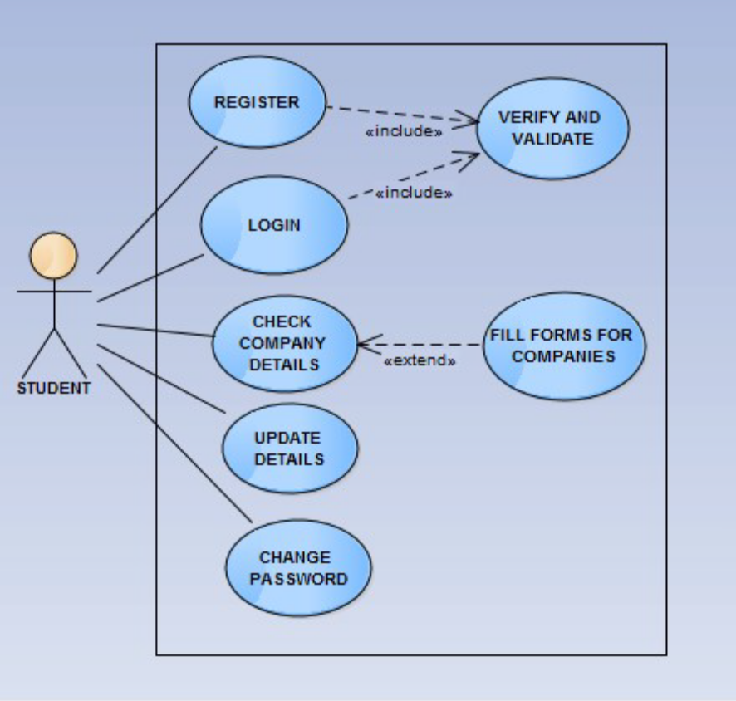
Appendix C: To Be Determined List
Not applicable

